Kirkland Village
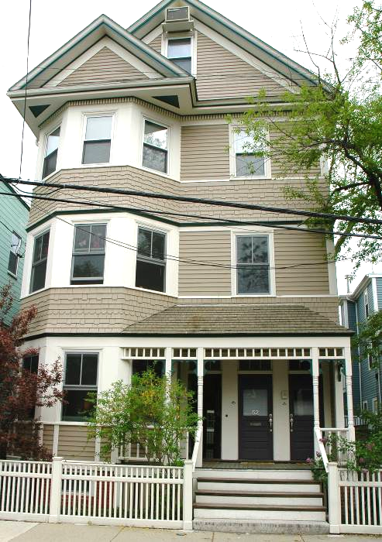
52 Roberts Road, Cambridge, MA
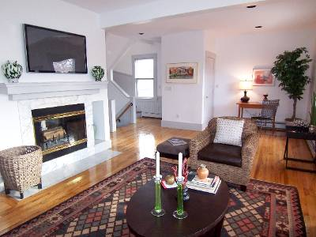  Lovely three bedroom duplex offering carefree living in Kirkland Village with easy access to both Harvard and Inman Squares. The first level features dramatic open living/dining space separated by double sided wood fireplace, bay windows, china cabinet, maple floors. The cook’s kitchen with double ovens, new dishwasher and breakfast bar has direct access to private deck. Additionally there is a large bedroom with two closets and full bath. There is a private entry with hall closet and two additional storage closets on the first level. |  |  | 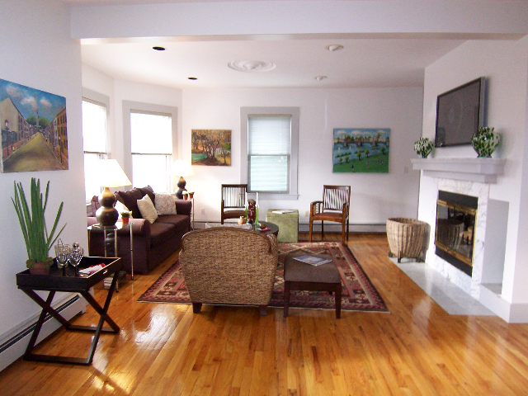
 |  |  | $759,000
  www.NewEnglandMoves.com | 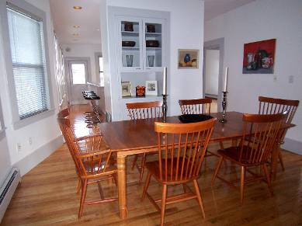 |  |  | Dura Maxfield Winder  Exclusive Listing Agent  office: 617.844-2767  fax: 617.876.7576  mobile: 617.285.8566  Dura.Winder@NEMoves.com  www.DuraWinder.com  WWW.Plum-Properties.com
THE PROPERTY  _____________________________________________________________________________________________________________________________  Elegant living is exemplified by the spacious rooms and well designed layout of this unit. The upper level opens into a hall landing with skylight. There are two bedrooms both with skylights and walk-in closets. The bath on this level has a double sized shower and washer/dryer closet. The back bedroom has a private deck. The views from the skylights are lovely treetop views and city vistas.  There is also private basement storage, one parking space in a heated garage with heated ramp. |  | Property Details  _____________________________________________________________________________________________________________________________________  LIVING AREA:  - +/- 2266 square feet  UNIT DETAILS:  - Two private decks.  - Main level: Open living room/dining room with a double sided wood burning fireplace and two bay windows. Dining room has china cabinet. The cook’s kitchen has lots of cabinet storage, breakfast-island, double ovens (one electric and one micro-wave/convection), new dishwasher, disposal, and refrigerator, There is one bedroom with two closets and door to rear deck and full bath off the hallway. There is an entry hall closet and an additional closets as you enter the unit on the upper level.  - Second level: Accessed by staircase opening to hall landing with skylight, two bedrooms (one with private deck) both with walk-in closets, cathedral ceilings and skylights. One bathroom with shower for two, ceramic tile floor and stack washer/dryer closet.  CONDO FEE:  - $286 Includes master insurance, maintenance, common electric and water/sewer.  TAXES:  - Taxes: $5,450 (Without residential exemption)  CONDOMINIUM DETAILS:  - 4 unit condo association  - Renovated 1990  - Two built-in air conditioners  - Assigned parking heated garage and garage ramp  - Common garden area  - Storage area in basement  