Kirkland Village
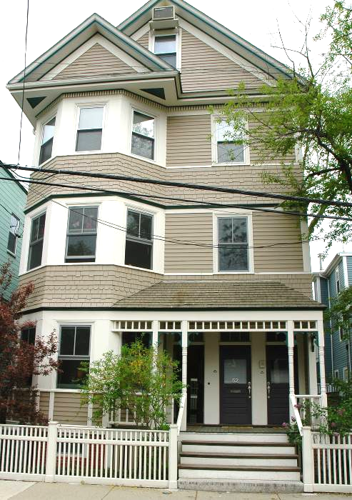
54 Roberts Road, Cambridge, MA
Lovely four bedroom duplex offering carefree living in Kirkland Village with easy access to both Harvard and Inman Squares. This unit features dramatic open living space on the first floor, maple floors, fireplace, bay windows and designer light fixtures. Highlights include maple and granite cook’s kitchen, master suite with spacious with elegant bathroom with steam shower, and private deck, central air conditioning, and a private city patio off the main kitchen. There is a private storage area, and one parking space in heated garage, with heated entrance ramp. |  |  |  | 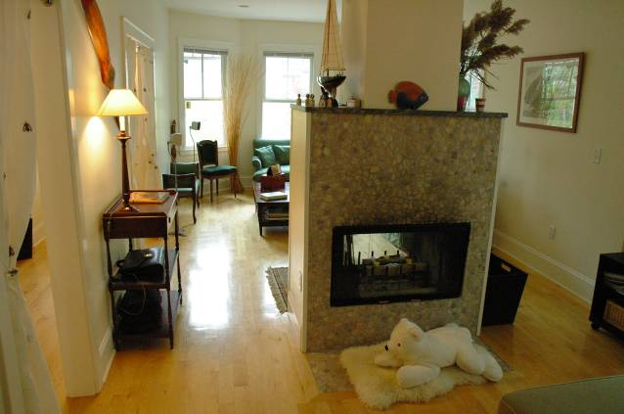
 |  |  |  | $739,000
  www.NewEnglandMoves.com | 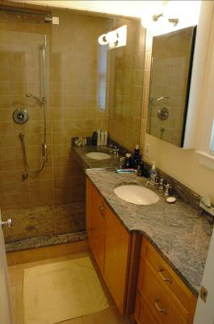 |  | Dura Winder  Exclusive Listing Agent  office: 617.864.8566 ext. 262  fax: 617.876.7576  mobile: 617.285.8566  Dura.Winder@NEMoves.com  www.DuraWinder.com
THE PROPERTY  _____________________________________________________________________________________________________________________________  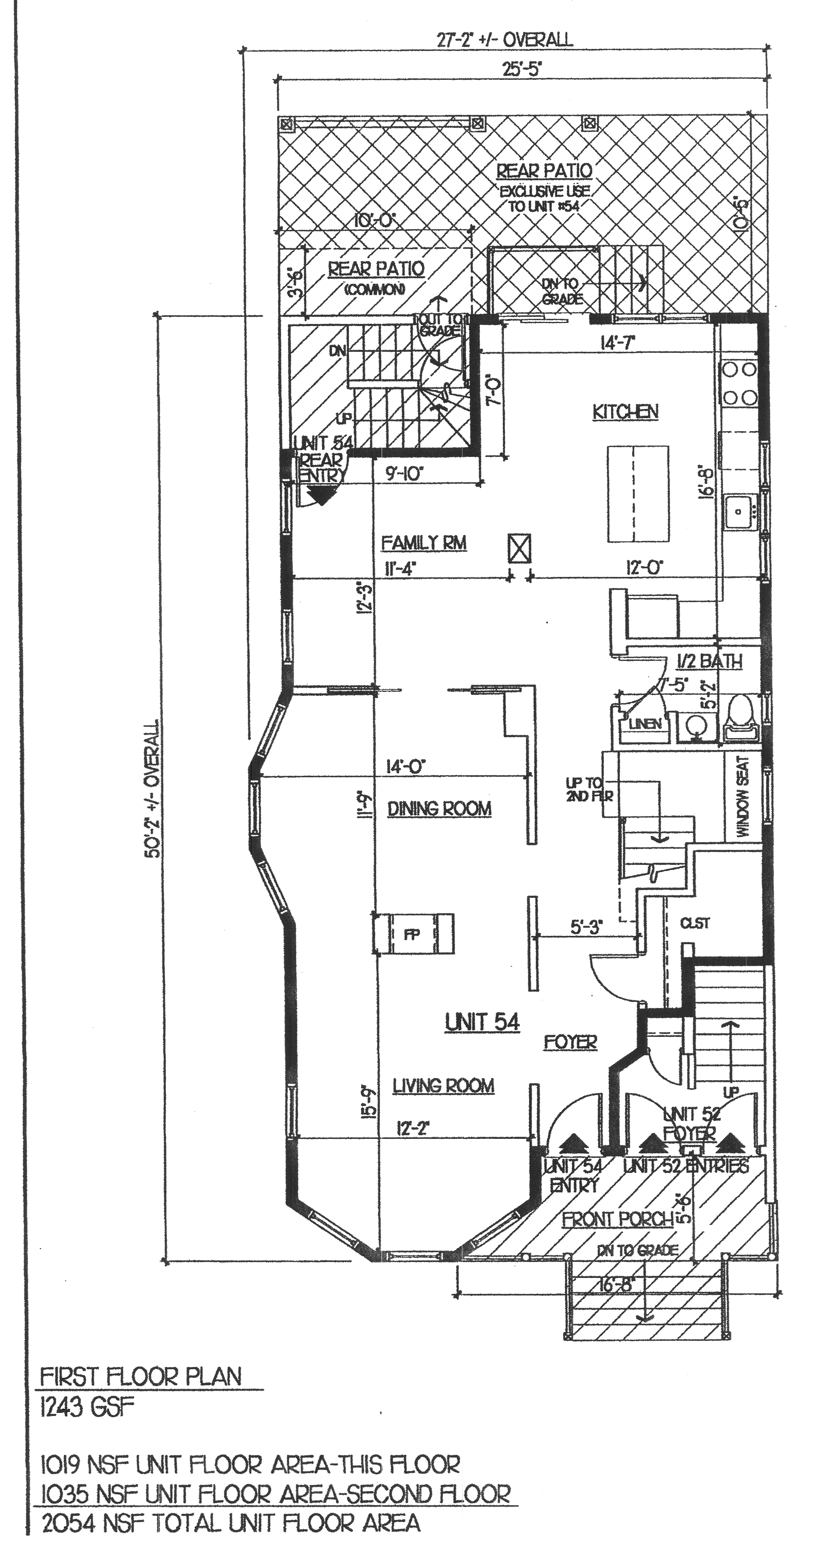  Elegant living is exemplified by the spacious rooms and well designed layout of this unit. The first level opens into a large living room and dining room with wood burning fireplace The gracious dining room features pocket doors leading to a comfortable family room off the elegant cook’s kitchen. There is a small back deck leading to and exclusive use brick patio. The light filled master bedroom has a private deck, his and her closets, and an exceptionally well appointed master bath. There are an additional three bedrooms, and another full bath. |  | Property Details  _____________________________________________________________________________________________________________________________________  LIVING AREA:  - +/- 2054 square feet  UNIT DETAILS:  - Front porch and fenced front yard area.  - Main level: Open living room and dining room with fireplace. Dining room has pocket doors leading into family room and cook’s kitchen with elegant granite countertops, plentiful maple cabinets, large farmer’s sink, center breakfast Island, gas stove with micro-wave/convection oven with vent hood, dishwasher, disposal, and refrigerator. Half- bath, off the hall with linen closet and entry hall with exceptionally deep coat closet.  - Second level: Accessed by staircase with small landing with window seat and stained glass window. Master bedroom has two closets, one of which is a walk-in, a private deck and handsome bathroom Master bath has a huge shower which can function as a steam room with rain hood shower head, hand shower, and has an in-shower shaving sink with heated mirror with ceramic tile floor, maple cabinetry, and granite counter tops. There are three additional bedrooms, a full bathroom also with tile, granite counters and maple cabinetry, and a stack washer/dryer.  CONDO FEE:  - $258 (Includes master insurance, maintenance, common electric and water/sewer.  TAXES: $5178.50 without residential exemption  CONDOMINIUM DETAILS:  - 4 unit condo association  - Renovated 2002  - Gas Forced Hot Air/Central Air  - Assigned parking heated garage and garage ramp  - Private patio and common garden area  - Assigned garage parking (heated)  - Storage area in basement  